Sprint Retrospective Notes

SEPT Team 03  
**Sprint 01**  
Date: 29AUG21  
  
**Attended**  
Scrum Master: Roman O’Brien  
Product Owner:   
Development team: David Morrin, Charlton Ho, Allen Muthupunnackal Jose  
  
**Things That Went Well**  
*What went well? What is the team happy about?*

* Enjoyed building FrontEnd with bootstrap, learning how to create user interfacing webpages
* Team collaborated and communicated frequently and successfully.
  + Team members were eager to resolve issues that arose and speak to teaching staff for help.

**Things That Could Have Gone Better**  
*What could have gone better? What could the team improve?*

* Team should have realised that the errors with the base code were inherent and not tried to solve them, asking for help earlier on.
  + The consultation with Homy was helpful but didn’t entirely resolve our problem.

**Things That Surprised Us**  
*What wasn’t expected?*

* Base code didn’t work
  + Took lots of team effort to attempt to resolve, was fruitless.
  + Too many complicated unknown variables to try to troubleshoot as beginners
  + Not enough comments in base code for beginners to understand.
* Information we needed to know wasn’t in the webinars nor in prerequisite subjects – not enough official resources for learning available.
  + Miscellaneous web tutorials aren’t self-consistent and difficult to learn from / understand the base code from.
  + Too many specific frameworks and packages that require a lot of learning to understand.

**Lessons Learnt**  
*What have we learnt from the points above?*

* Ask questions early.
* If you haven’t done a task before, expect it to take three times as long.
* Teaching staff may not actually resolve your issue.
* Problems would be much simpler to resolve face to face.

**Final Thoughts**  
*Things to keep. Things to change.*

* Team should be more conservative in our Sprint Planning
  + Did not finish a single user story.
* Keep the drive for consistent progress.

**Burndown Chart**

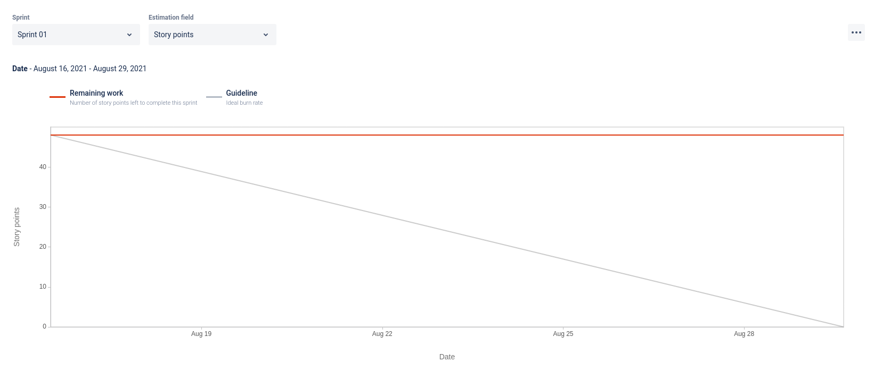

**Cumulative Flow Diagram**

